**Adaptive Online Learning Platform to Enhance Primary Education**

**Delivering customized quizzes to enhance and strengthen emotional intelligence.**

Project ID : TMP-2023-24-091

PROJECT PROPOSAL REPORT

Hapuarachchi H. D. I. C.

B.Sc. (Hons) in Information Technology Specializing in Data Science

Department of Computer Science

Sri Lanka Institute of Information Technology

Sri Lanka

August 2023

**Adaptive Online Learning Platform to Enhance Primary Education**

**Delivering customized quizzes to enhance and strengthen emotional intelligence.**

Project ID : TMP-2023-24-091

PROJECT PROPOSAL REPORT

Hapuarachchi H. D. I. C.

B.Sc. (Hons) in Information Technology Specializing in Data Science

Department of Computer Science

Sri Lanka Institute of Information Technology

Sri Lanka

August 2023

DECLERATION

We declare that this is our own work, and this proposal does not incorporate without acknowledgement any material previously submitted for a degree or diploma in any other university or Institute of higher learning and to the best of our knowledge and belief it does not contain any material previously published or written by another person except where the acknowledgement is made in the text.

|  |  |  |
| --- | --- | --- |
| Name | Student ID | Signature |
| Hapuarachchi H.D.I.C. | IT20617264 |  |

The supervisor/s should certify the proposal report with the following declaration.

The above candidates are carrying out research for the undergraduate Dissertation under my supervision.

|  |  |
| --- | --- |
| Name | Signature |
| Supervisor:  Mr. Samadhi Rathnayaka |  |
| Co-Supervisor:  Dr. Dharshana Kasthurirathna |  |

ABSTRACT

In the domain of education and psychology research, there is a growing emphasis on the exploration of children's emotional intelligence. Identifying and addressing early signs of emotional weaknesses holds the potential to preempt future emotional challenges. However, the availability of online platforms dedicated to fostering children's emotional intelligence remains limited.

To address this gap, this study seeks to provide children with a specialized platform that offers personalized activities, cultivating their emotional intelligence during their formative years. To achieve this goal, we propose an integration of Reinforcement Learning (RL) and generative Artificial Intelligence (AI). The fundamental approach involves presenting children with context-rich decision-making scenarios that evoke emotional responses. The crux lies in associating a child's decisions within these scenarios with the revelation of underlying emotional vulnerabilities.

Within the realm of personalization, the utilization of reinforcement learning holds the potential to enhance recommendations and user engagement by adapting to individual emotional nuances and needs. Simultaneously, generative AI simplifies the creation of tailored activities, allowing more concerted efforts toward analyzing children's emotional progress and refining the activities. This combined approach synergistically optimizes personalization and operational efficiency.

Central to this study is the proposition of an integrated system, where Reinforcement Learning and generative AI collaborate to orchestrate a finely tuned activity framework. The aim is to effectively address individual emotional inclinations and vulnerabilities, thereby fostering the cultivation of heightened emotional intelligence.

TABLE OF CONTENT

Contents

INTRODUCTION 7

BACKGROUND AND LITERATURE REVIEW 9

Personalization 9

Emotional Intelligence 12

Quiz Generation 13

RESEARCH GAP 14

RESEARCH PROBLEM 15

OBJECTIVES 16

Main objective 16

Specific objectives 16

METHODOLOGY 17

LIMITATIONS AND CHALLENGES 19

PROJECT REQUIREMENTS 20

Functional Requirements 20

Non-Functional Requirements 21

References 22

LIST OF FIGURES

Fig 1 – Figure from research paper

Fig 2 – Figure from research paper

Fig 3 – Figure from research paper

Fig 4 – Overall System Diagram

LIST OF TABLES

Table 1 – Research Gaps

# INTRODUCTION

Developing emotional intelligence (EI) through the innovative integration of Reinforcement Learning (RL) and Generative Artificial Intelligence (Gen AI) presents a promising avenue that amalgamates psychological insight, machine learning expertise, and advancements in artificial intelligence. EI, a multifaceted skill set encompassing the recognition, understanding, management, and effective utilization of emotions in oneself and others, holds pivotal importance in diverse social and interpersonal contexts.

Reinforcement Learning, a subset of machine learning, involves an agent learning actions to maximize rewards in a given environment. This process revolves around trial and error, where the agent receives feedback in the form of rewards or penalties based on its actions. In the context of enhancing emotional intelligence, the strategic combination of Reinforcement Learning and Generative Artificial Intelligence can yield unprecedented efficiency compared to traditional approaches.

By synergizing the intrinsic capabilities of RL to optimize decision-making within dynamic and uncertain scenarios and Gen AI's capacity to simulate intricate emotional contexts, this fusion offers the potential to expedite the acquisition of nuanced emotional skills. This approach can potentially overcome the limitations of didactic methods by providing immersive experiences mirroring real-world emotional dynamics, fostering adaptable and robust emotional intelligence outcomes.

The landscape of RL for Generative AI primarily falls within three categories: using RL as an alternative solution for output generation without predefined objectives, generating output while simultaneously maximizing an objective function, and embedding desired characteristics into the generative process. Recent advancements in RL concentrate on augmenting generalization, the model's ability to apply learned knowledge to new and unseen situations. Techniques like policy similarity metrics and contrastive metric embeddings contribute to this improved generalization.

Given the nascent nature of combining Reinforcement Learning and Generative AI, comprehensive research exploring their synergy for nurturing emotional intelligence remains limited. This study marks a pioneering effort in investigating the applications and implications of RL within generative deep learning to foster emotional intelligence in humans.

In conclusion, the fusion of Reinforcement Learning and Generative AI holds immense promise for bolstering emotional intelligence. The subsequent sections delve into the intricacies of this groundbreaking approach, shedding light on its potential benefits and challenges, and providing a comprehensive overview of its applications and significance.

# BACKGROUND AND LITERATURE REVIEW

## Personalization

In the ever-advancing realm of reinforcement learning (RL), despite notable progress, a persistent challenge remains—the considerable number of interactions required within an environment for effective agent learning. This becomes particularly pertinent in realistic scenarios where such interactions can be prohibitively expensive. To tackle this concern, innovative strategies such as transfer learning have been seamlessly integrated with reinforcement learning, offering a solution wherein insights gained from one task can be harnessed when embarking on a more complex subsequent task [1] Moreover, to enhance the efficiency of the learning process, a fusion of deep neural networks, reinforcement learning, and supervised learning techniques has been embraced [2].

Among the diverse educational landscapes that have embraced innovation, the pursuit of personalized academic experiences stands prominent. One embodiment of this aspiration is the Intelligent Student Profiling with Fuzzy Models system [3]. In this system, a meticulous record of students' educational interactions and learning engagements is meticulously maintained, stored within an encompassing student profile database. This repository of accumulated profiling data then takes shape as a comprehensive student model. This synthesis of individual characteristics, blended with a content-oriented model, becomes the cornerstone for generating adaptive learning pathways tailored to each student's unique attributes. Through this strategic amalgamation, the system is empowered to seamlessly curate personalized educational resources, craft customized quizzes, and provide highly-individualized guidance. The resultant impact is a dynamic educational experience that caters to the ever-evolving needs of learners.

Recent times have witnessed a pronounced surge in the integration of Reinforcement Learning (RL) into systems facilitating human interactions. This trend reflects RL's remarkable capacity to tailor digital systems, rendering them more relevant and responsive to each user's distinct needs. A noteworthy application of this trend can be found in a study where a deep reinforcement learning approach was leveraged for recommending personalized medical choices, including medicines, doctors, nutrition, exercises, and sports based on individual patient requirements. Importantly, this model operates in a perpetually updated manner, incorporating real-time feedback [4] .

Intriguingly, while the utilization of RL in various domains is on the rise, a nuanced perspective emerges. A study notes that the inclusion of a comparison or realistic evaluation involving RL is not consistently growing. Moreover, the majority of algorithms are employed on a one-time basis, highlighting potential untapped opportunities for more robust adoption and exploration [5] .

As educational paradigms continue to evolve, the imperative for adaptability becomes increasingly evident. This necessity is aptly captured by the assertion that, "With the plethora of educational and e-learning systems and the great variation in students’ personal and social factors that affect their learning behaviors and outcomes, it has become mandatory for all educational systems to adapt to the variability of these factors for each student" [6]

To this end, a personalized adaptability knowledge extraction strategy (PAKES) emerges, employing a blend of cognitive diagnosis and reinforcement learning. This approach capitalizes on a general diagnostic model to track individual learners' knowledge states. Subsequently, an RL-based Q-learning algorithm is employed to curate optimal pedagogical instructions. This dual objective of meeting learning goals while ensuring harmony between learner control and teaching trajectories underscores the system's holistic approach [7]

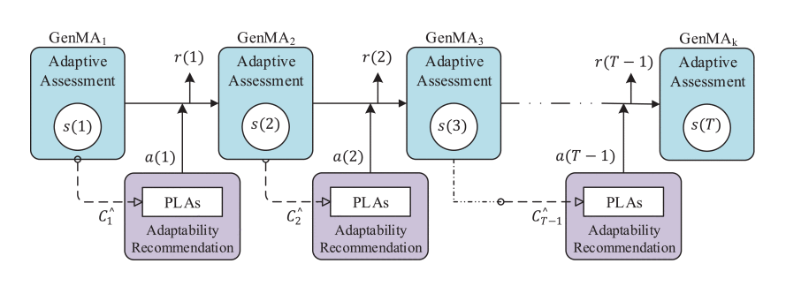

Framework of personalization system

Fig 1

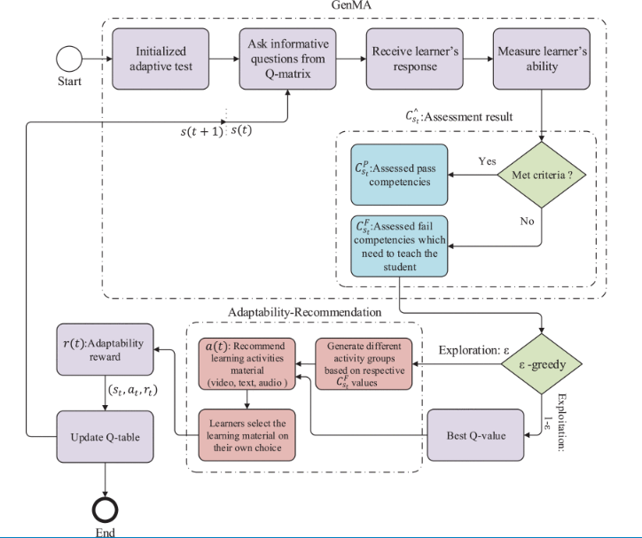

Flow chart

Fig 2

In the landscape of collaborative learning scenarios, a significant stride has been taken to adapt to prevailing factors through an innovative method [6] .This method harnesses the capabilities of reinforcement learning to construct an intelligent environment that serves a dual purpose: recommending suitable learning resources and orchestrating a strategy to cater to the evolving states of students, including their technology acceptance levels. Rigorous assessments conducted through simulation reveal the system's promising performance, underscoring the efficacy of the proposed approach. Notably, this approach diverges according to individual learners and distinct learning contexts, effectively encompassing both solitary and collaborative learning environments.

An equally compelling proposition emerges in [8] , where the integration of contextual bandits and reinforcement learning has demonstrated its effectiveness in dynamic educational settings. In this framework, the utilization of both past student behaviors and their present states as contextual information underpins the formulation of the policy guiding the reinforcement agent's decision-making. The evaluation of this method unfolds through the lens of real data extracted from an online learning system, offering a tangible demonstration of its applicability and potential impact on enhancing learning experiences.

## Emotional Intelligence

The world of Reinforcement Learning (RL) mirrors the role that emotions play in decision-making, as both concepts involve learning from experiences to adapt and respond effectively to their respective environments. This parallel becomes particularly significant in the context of Emotional Intelligence (EI) among primary students, where EI's impact is intertwined with variables such as school engagement, social adjustment, emotion regulation, and academic performance [9]

In the realm of harnessing emotions for enhanced learning experiences, recent research has yielded intriguing insights. An exemplary study [10] introduces a pioneering framework known as Emotion Detection based Reinforcement Learning Framework (EDRLF). This framework tackles the intricate challenge of detecting emotions within conversational contexts. It accomplishes this by seamlessly integrating the progressive aggregation of emotional nuances through a reinforcement learning mechanism. What sets EDRLF apart is its ability to not only identify emotions but also to structure and weave these aggregated emotional insights with contextual data. This synergy culminates in the formation of a comprehensive framework state, thereby amplifying its overall performance.

EDRLF shines particularly in its aptitude to navigate the intricate emotional dynamics that unfold across successive utterances during conversations. By employing a reinforcement learning approach, EDRLF attunes itself to these evolving emotional landscapes, resulting in an elevated capacity to extract nuanced emotional information. This amalgamation of emotion and learning holds the promise of revolutionizing how emotions are detected, understood, and harnessed within the realm of educational interactions.

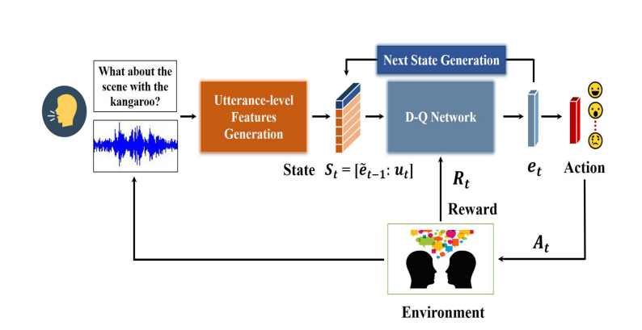

The proposed system is as above

Fig 3

## Quiz Generation

In the pursuit of refining text generation, recent efforts have sought to overcome challenges posed by autoregressive models and maximum likelihood estimation [11] . One novel strategy involves recontextualizing text generation by framing it as an offline reinforcement learning (RL) challenge, synergized with expert demonstrations. The paramount goal is to optimize text quality while navigating the complexities of working with model-generated histories. This innovation introduces GOLD (Generating Off-policy by Learning from Demonstrations), a sophisticated algorithm meticulously crafted to effectively leverage expert demonstrations through the mechanism of importance weighting.

Building upon this momentum, another intriguing endeavor [12] unveils a model with the prowess to generate responses imbued with emotional appropriateness in text messaging scenarios. The foundation of this accomplishment rests on a reinforcement-learning framework, honed through the policy gradient method, thereby enabling the model to acquire the skill of crafting contextually fitting responses.

Expanding the realm of text-based innovations, the inception of EduQuiz is notable [13] . This comprehensive quiz generator operates on the premise of an end-to-end design, employing a GPT-3 model fine-tuned using text-quiz pairs. The outcome is a system adept at formulating complete multiple-choice questions, complete with both correct answers and distractors. Notably, the quiz generation process is underpinned by the capabilities of generative pre-trained transformers, epitomizing the synergy between advanced text generation techniques and educational applications.

# RESEARCH GAP

Accurately identifying and supporting kids' emotional wellbeing in the setting of elementary school has become essential to promoting holistic development. The focus has largely been on cognitive components, with little attention paid to emotional intelligence, even if many educational systems have been adapted to personalize learning experiences. This discrepancy highlights a critical weakness in meeting the emotional requirements of young students. To close this gap, a ground-breaking strategy is introduced, one that combines the strength of Generative Artificial Intelligence (AI) and Reinforcement Learning (RL) to create customized tests that deftly explore and gracefully address emotional vulnerabilities.

This cutting-edge method outlines several goals. It primarily aims to depart from traditional cognitive-centered paradigms by promoting emotional intelligence. This strategy seeks to recalibrate educational paradigms considering the significant influence that emotional health has on the educational process. Fundamentally, the system makes use of Generative AI to create tests that are especially suited to each student's emotional state. These tests are purposefully made to covertly identify emotional weaknesses, in contrast to traditional methods that directly confront people with questions about their feelings.

The incorporation of Reinforcement Learning, a sophisticated machine learning method that enables adaptive refinement, is fundamental to the system's architecture. The system evolves dynamically because of the ongoing assimilation of knowledge from student replies and behavioral patterns, improving its ability to precisely identify emotional vulnerabilities. Through this complex process, the system's accuracy in emotional evaluation steadily improves, leading to a better understanding of the emotional landscapes of students.

Some of the existing research related to the field with their gaps are mentioned below,

|  |  |  |  |  |  |  |  |  |  |
| --- | --- | --- | --- | --- | --- | --- | --- | --- | --- |
|  | [1] | [6] | [7] | [8] | [9] | [10] | [11] | [12] | [13] |
| Emotional Intelligence | No | No | No | No | Yes | Yes | No | No | No |
| Reinforcement Learning | Yes | Yes | Yes | Yes | No | Yes | Yes | Yes | No |
| Personalization | Yes | Yes | Yes | No | No | No | No | No | No |
| Gen AI | No | No | No | No | No | No | No | No | Yes |
| Quiz/Text  generation | No | No | Yes | No | No | No | Yes | Yes | Yes |

Table 1

# RESEARCH PROBLEM

A proposed model that cleverly combines reinforcement learning (RL) with generative artificial intelligence (genAI) offers a solution to the problem of the current lack of systems that address emotional intelligence. This novel strategy is based on an engaging story-based decision-making test that was specifically designed to not only identify but also address the emotional intelligence gaps.

This innovative model's ability to pinpoint and distinguish the precise emotional intelligence domains in need of improvement is at its core. The technique effectively captures situations in which emotional intelligence may show limitations by immersing elementary pupils in narrative-driven settings that elicit emotional responses. The foundation for the succeeding quiz phase is subsequently laid by this keen recognition.

This is where the combined use of RL and genAI reaches its full potential. By creating follow-up questions that explicitly address the observed emotional intelligence deficits, the program dynamically changes its progression. The learning process is made to be both deeply insightful and individualized thanks to this subtle methodology. While the genAI component permits the generation of contextually relevant and interesting content, the merging of RL enables the system to fine-tune its recommendations based on the user's interactions.

Essentially, this suggested combination of RL and genAI results in a breakthrough solution that goes beyond traditional academic examinations. By emphasizing emotional intelligence, it forays into the area of human growth and development, encouraging the abilities and awareness required for traversing challenging emotional environments. This concept not only addresses the lack of emotional intelligence-focused systems but also lays the framework for a new paradigm in educational technology that fosters the emotional health of young children.

# OBJECTIVES

## Main objective

* To build a platform to reduce the gap of academic performance and Emotional Intelligence of Primary students.

## Specific objectives

* Delivering customized quizzes to enhance and strengthen individual personality skills that may require further development.
* Identifying emotional strengths/weaknesses of an individual based on the decisions taken.
* Using Reinforcement Learning to build the environment (next story) with generative AI.

# METHODOLOGY

A ground-breaking approach to personalization in education is provided by the partnership of reinforcement learning (RL) and generative artificial intelligence (AI), where content is personalized to each student while also aligning their emotional and cognitive needs. This novel combination derives its essence from an innovative approach in which RL acts as the cognitive catalyst, refining the Generative AI outputs to create beautifully customized experiences that promote emotional intelligence.

RL interacts with a Generative AI model as the first phase progresses. The AI creates context-rich material in this dynamic and presents users with scenario-based decision-making questions. These inquiries are intended to reveal users' emotional frailties and encourage them to make decisions that are consistent with those tendencies.

The reactions and choices users make as they engage with these scenario-based questions are scrupulously documented. The RL agent develops into an astute observer, gaining complex behavioral insights. These interactions, which are essential to the RL-GAI synergy, allow patterns reflecting users' emotional proclivities and aptitudes to be extracted from their decisions. The reward signal, a guiding parameter through which the RL agent determines content quality based on user reactions, is a crucial aspect that is introduced here. This signal assesses how well users were able to understand and control their emotional complexities as it relates to emotional vulnerability investigation.

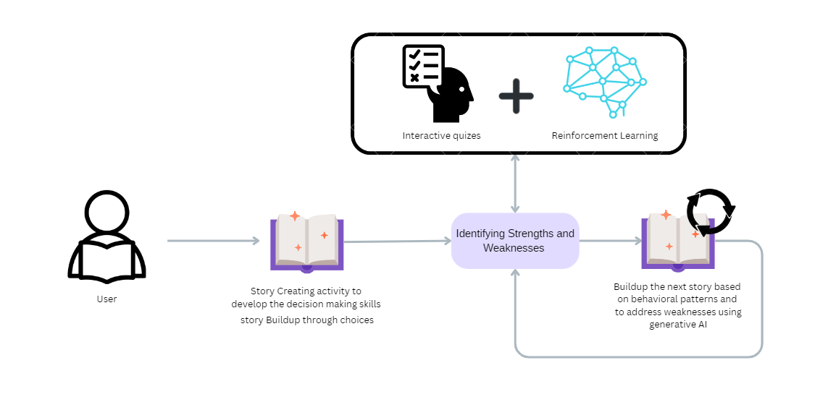

Fig 4

The adaptive learning method is where this joint project really shines. The RL agent continuously improves its content selection or generation strategy under the guidance of a continuous cycle of learning from mistakes. It tends to produce inquiries that have previously elicited helpful responses, adjusting the content to match users' emotional landscapes.

Additionally, the symbiotic role of Generative AI is evident in the creation of new tests that focus on users' emotional vulnerabilities. The AI creates quizzes that are specifically focused on those emotional aspects that need nurturing by extrapolating knowledge from the RL agent's examination of user decisions. These tests are designed to highlight emotional strengths while resolving weaknesses. The created tests offer thorough explanations of the best decisions within these scenarios, going beyond simple assessment. Users are given the skills necessary to better handle emotional complexity thanks to this proactive approach.

# LIMITATIONS AND CHALLENGES

1. **Ethical Considerations:** Ensuring proper informed consent, data privacy, and protecting vulnerable participants like primary students would be challenging yet essential.
2. **Sample Size and Diversity:** Obtaining a diverse sample of primary students while managing the consent process could be time-consuming and resource-intensive.
3. **Generalizability:** The findings might be specific to the chosen context, making it challenging to generalize to different educational settings.
4. **Emotion Detection Accuracy:** The accuracy of emotion detection from students' responses might be impacted by various factors, including cultural nuances and developmental differences.
5. **Long-term Impact:** Determining the long-term impact of emotional intelligence development on students' well-being and academic success might require extended follow-up periods.
6. **Model Complexity and Adaptation:** Balancing the complexity of the RL and genAI models with their efficacy for primary students' emotional development would be a continuous challenge.
7. **Teacher and Parent Involvement:** Involving teachers and parents in the process and ensuring their cooperation might pose logistical challenges.

# PROJECT REQUIREMENTS

## Functional Requirements

1. **Emotion Detection and Analysis:**

**A**ccurately detect and analyze emotions from students' responses in order to identify emotional weaknesses.

1. **Personalized Quiz Generation:**

Generate personalized quizzes that are tailored to each student's emotional profile and weaknesses.

1. **Reinforcement Learning Integration:**

Integrate reinforcement learning techniques to adapt and refine the personalized quizzes based on students' interactions and feedback.

1. **Real-time Feedback:**

Allow real-time feedback to be collected and used to update the model, ensuring continuous improvement.

1. **Learning Trajectories:**

Dynamically adjust the learning pathways for individual students based on their emotional progress and evolving needs.

1. **Usability:**

User-friendly and accessible for primary students, teachers, and parents, ensuring ease of use and engagement.

## Non-Functional Requirements

1. **Accuracy and Reliability:** The emotion detection and analysis component should exhibit a high degree of accuracy and reliability to ensure meaningful results.
2. **Privacy and Security:** The system should prioritize the privacy and security of students' data, adhering to data protection regulations.
3. **Scalability:** The system should be designed to accommodate a growing number of students and their interactions without compromising performance.
4. **Adaptability:** The system should be adaptable to different learning contexts, catering to diverse emotional needs and educational settings.
5. **Responsiveness:** The system should respond promptly to user interactions, providing seamless user experiences.
6. **Interoperability:** The system should be capable of integrating with existing educational technologies and platforms.
7. **Ethical Considerations:** The system should adhere to ethical guidelines, particularly when dealing with young learners, ensuring their well-being and respecting cultural sensitivities.
8. **Feedback Mechanism:** The system should provide clear and constructive feedback to students, teachers, and parents, aiding their understanding of emotional progress.

# References

|  |  |
| --- | --- |
| [1] | S. Narvekar, B. Peng, M. Leonetti, J. Sinapov, M. E. Taylor and P. Stone, "Curriculum learning for reinforcement learning domains: A framework and survey," 17 September 2020. |
| [2] | D. Silver, A. Huang, C. J. Maddison, A. Guez, L. Sifre, G. van den Driessche, J. Schrittwieser, I. Antonoglou, V. Panneershelvam, M. Lanctot, S. Dieleman, D. Grewe, J. Nham, N. Kalchbrenner, I. Sutskever, T. Lillicrap, M. Leach, K. Kavukcuoglu, T. Graepel and D. Hassabis, "Mastering the game of go with deep neural networks and Tree Search," vol. 529, no. 7587, 2016. |
| [3] | Dongming Xu, Huaiqing Wang and Kaile Su, "Intelligent student profiling with Fuzzy models". |
| [4] | J. Mulani, S. Heda, K. Tumdi, J. Patel, H. Chhinkaniwala and J. Patel, "Deep reinforcement learning based personalized health recommendations," 2019. |
| [5] | F. den Hengst, E. M. Grua, A. el Hassouni and M. Hoogendoorn, "Reinforcement learning for personalization: A systematic literature review," 2020. |
| [6] | D. Shawky and A. Badawi, "A reinforcement learning-based Adaptive Learning System," *The International Conference on Advanced Machine Learning Technologies and Applications (AMLTA2018),* 2018. |
| [7] | M. Z. Islam, R. Ali, A. Haider, M. Z. Islam and H. S. Kim, "Pakes: A reinforcement learning-based personalized adaptability knowledge extraction strategy for Adaptive Learning Systems," 2021. |
| [8] | W. Intayoad, C. Kamyod and P. Temdee, "Reinforcement learning based on Contextual Bandits for Personalized Online Learning Recommendation Systems," 2020. |
| [9] | P. Gershon and J. Pellitteri, "Promoting emotional intelligence in preschool education: A review of programs.," 2018. |
| [10] | X. Huang, M. Ren, Q. Han, X. Shi, J. Nie, W. Nie and A.-A. Liu, "Emotion detection for conversations based on Reinforcement Learning Framework," 2021. |
| [11] | R. Y. Pang and H. He, "Text generation by learning from demonstrations," 03 March 2021. |
| [12] | V. Srinivasan, S. Santhanam and S. Shaikh, "Using reinforcement learning with external rewards for open-domain natural language generation," 2020. |
| [13] | R. Dijkstra, Z. Gen¸c, S. Kayal and J. Kamps, "Reading Comprehension Quiz Generation using". |